User Guide of FragMe

# Introduction

FragMe is a Java framework which is used to develop peer-to-peer applications. It provides the management of the peers and their shared objects. Message transmissions and peer discovery are provided by a stripped down version of JGroups. JGroups provides peer discovery using multicast protocol and the message between peers can be sent using multicast or unicast.

FragMe can be used for Android and Desktop application development. The applications could be multiplayer games and any kind of social networking applications.

# FragMe API

The FragMe framework provides an interface to develop applications. Basically it includes two parts: one is shared object and one is peer connection setup.

## Build shared objects.

When starting an application, peers need to create objects or get shared objects from other peers. FragMe framework provides management of the objects and provides *FMeObject* abstract class. We need to import three related FragMe classes:

***import*** *org.nzdis.fragme.factory.FactoryObject;*

***import*** *org.nzdis.fragme.factory.FragMeFactory;*

***import*** *org.nzdis.fragme.objects.FMeObject;*

The shared objects in the application need to extend the *FMeObject* and implement the abstract method. For example:

public class TicTacToeModel extends FmeObject {

}

Also the constructor must not have any parameters to be conforming to the implementation of the factory pattern. If an initialisation with parameters is needed for this object, use a separate initialisation method. A private constructor used could prevent normal instantiation. This is because FragMe needs to control all objects. For example:

***private*** *TicTacToeModel() {*

*}*

Besides, the object class needs its own private FragMeFactory subclass to enable FragMe factory support. This factory enables access to all of the functionality of the Factory. For example,

*private static class Factory extends FragMeFactory {*

*protected FactoryObject create() {*

*return new TicTacToeModel();*

*}*

*}*

Next the private factory has to be registered with the single FragMeFactory for this application.

This is done by using a static constructor:

***static*** *{*

*FragMeFactory.addFactory(****new*** *Factory(),*

*TicTacToeModel.****class****);*

*}*

Since the object extends the *FMeObject* class, three inherited methods need to be implemented, *changedObject(),deletedObject(),* and *deserialize(FmeObject serObject).* For example:

*public void changedObject() {*

*this.setChanged();*

*this.notifyObservers();*

*}*

*public void deletedObject() {*

*this.setChanged();*

*this.notifyObservers();*

*}*

*public void deserialize(FmeObject serObject) {*

*this.positions = ((TicTacToeModel) serObject).getPositions();*

*this.lastMove = ((TicTacToeModel) serObject).getLastMove();*

*}*

The method *changedObject()* is called when the object is changed and the method *deletedObject()* is called when the object is deleted. The method *deserialize()* is responsible for deserialising your data. It is called whenever a serialized object containing the data of this *FmeObject* is needed. This is done in the FragMe framework by calling the change() method of the FragMe Object. For example:

*tModel.change();*

If only one field is changed, the name of the field can be parsed into the change() method and only changes to that field will be sent to other peers. For example:

*tModel.change(tModel.getClass().getField(“positions”).getName());*

When this method is called it serializes the current object using the serialized version and then sends it to the other peers where it is deserialize and the new values of the fields are coped over to the FragMe object.

## Set up connection of peers.

After we have shared objects built up, we can use that for the connection setup between peers. The related FragMe classes are:

***import*** *org.nzdis.fragme.ControlCenter;*

***import*** *org.nzdis.fragme.helpers.StartupWaitForObjects;*

***import*** *org.nzdis.fragme.util.NetworkUtils;*

1. Set up local network address used to connect to other peers

The address is a string type. For example:

*String* address=”127.0.0.1”

If you want to pick up a local non-loopback address, you can call *NetworkUtils.* For example:

*String address = NetworkUtils*

*.getNonLoopBackAddressByProtocol(NetworkUtils.IPV4);*

This will get a local IPV4 type address.

* 1. Set up peer name

A peer name is needed to set up a connection. It is a string type. For example,

*String user =System.getProperty("user.name");*

* 1. Set up connection

FragMe provides ControlCenter class to help setup the connection of the peers. Developers can use it without the need to worry about any underlying code in the framework. To set up a connection, we need to use

*ControlCenter.setUpConnections(String groupName, String peerName, String bindAddress)*

When peers start up at the same time, we might need to use

*ControlCenter.setUpConnectionsWithHelper("TicTacToe", user, address,*

***new*** *StartupWaitForObjects(1));*

Class *StartupWaitForObjects* provides a method to wait other peers setting up object storage so that new peer can get the shared objects.

The *ControlCenter.setUpConnections()* method contains all the setup code to get a FragMe application running. It creates the network connection and notifies the others a new peer has joined. It also takes care of setting up the initial objects. The example above is from the TicTacToe application and therefore the group it joins to is “tictactoe” with its peer name and local bind address.

2.4 Create and obtain shared objects

After the connection is setup, if there is a peer already there, we need to receive all the shared objects currently in the application from that peer. This is done by calling the *getAllObjects()* method.

*Vector shareObjects = ControlCenter.getAllObjects();*

This method then returns a vector of all the FragMe objects in the game.

If there is no other peer, we need to create objects. New FragMe objects cannot just be created by using the new keyword. Instead we must use the *ControlCenter* method *createNewObject*. This is because the FragMe framework uses the Factory Pattern in order to have absolute control over instantiating of relevant FragMe objects and to encapsulate object creation in one place. This then allows for sophisticated memory management, as the user cannot simply build instances of these objects, but must use the factory class. The following is an example from the TicTacToe application of how to create a new FragMe object.

*tModel = (TicTacToeModel) ControlCenter*

*.createNewObject(TicTacToeModel.****class****);*

# Android Application Development

We are now using the simple game TicTacToe as an example to explain how to develop an Android application using FragMe. TicTacToe is a traditional pencil-and-paper game for two players, O and X. The player who succeeds in placing three of their marks in a horizontal, vertical, or diagonal row wins the game.

## Install Eclipse and Android SDK

* 1. Install Eclipse
     + Download Eclipse from <http://eclipse.org/downloads/> and choose Eclipse IDE for Java Developers package.
     + Install Eclipse on local machine. You might need to install the latest Java JDK and JRE first.
  2. Install Android SDK plugins
     + Run Eclipse and choose Help->Install New Software.
     + Click *Add* in the Available Software window.
     + Enter *Android Development Tools* in the *Name* field, and https://dl-ssl.google.com/android/eclipse/ in the *Location* field.
     + Click *OK* and check *Developer Tools* in the list of available software. This will install the Android Development Tools and DDMS, Android’s debugging tool.

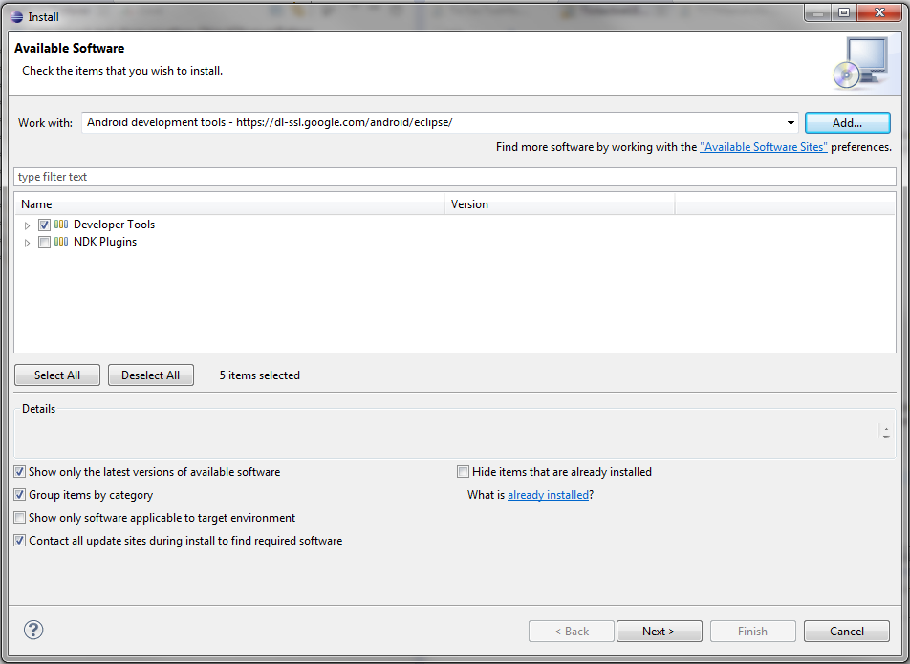

* 1. Click *Next* and *Finish* to install the plugin. You’ll need to restart Eclipse once everything is installed.
  2. When Eclipse restarts, choose *Window->Preferences* and you should see *Android* listed in the categories.
  3. You now need to tell Eclipse where you’ve installed the Android SDK. Click *Android* and then *Browse* to select the location where you extracted the SDK files. For example, *D:\HSitu\android-sdks*.

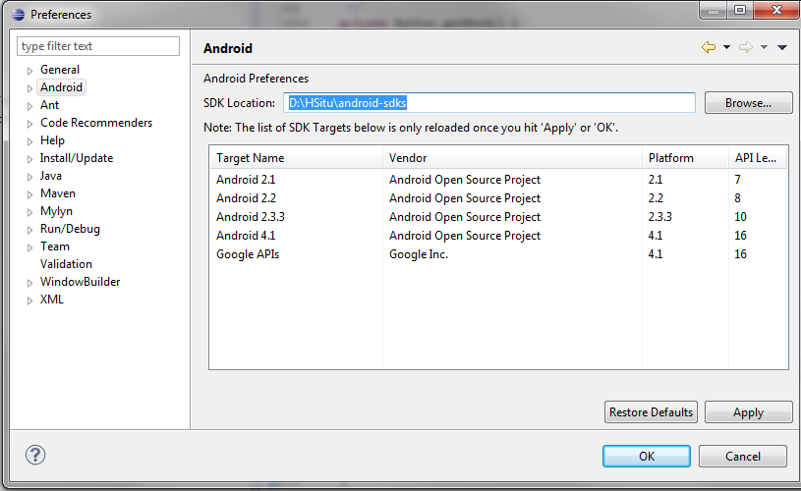

* 1. Click *OK* to save the Android SDK location.
  2. Choose *Window->Preferences->Android SDK Manager* to install specific Android API version, such as Android 2.2 (API 8) and Android 4.1 (API 16).

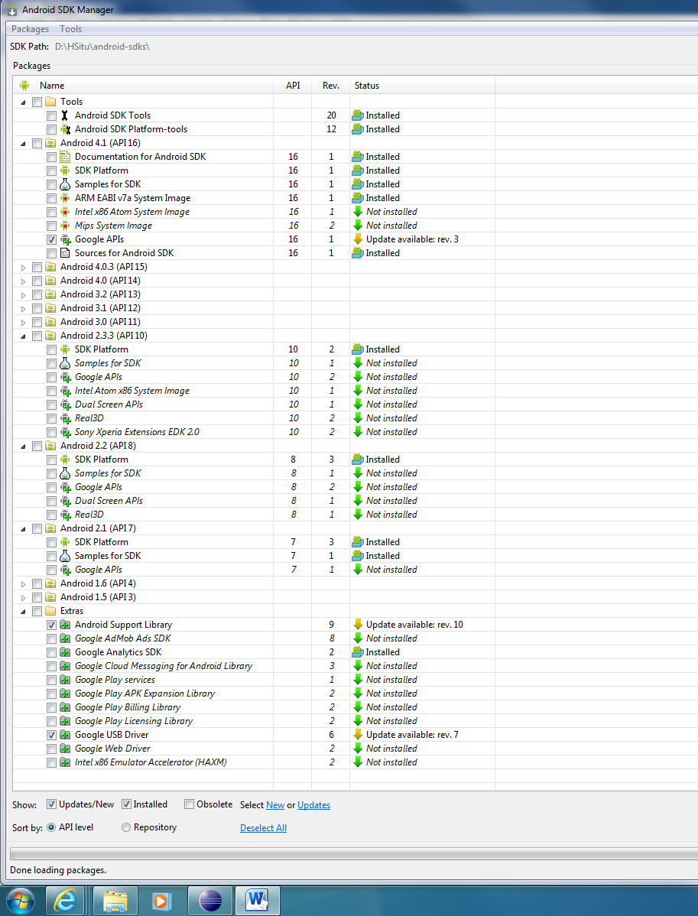

## Create an Android project

* 1. Choose *File->New->Android Application Project*.
* Input names in the fields of *Application Name, Project Name and Package Name.*
* Choose the Android SDK version. The *Minimum Required SDK* means the earliest version of Android on which your application will run.

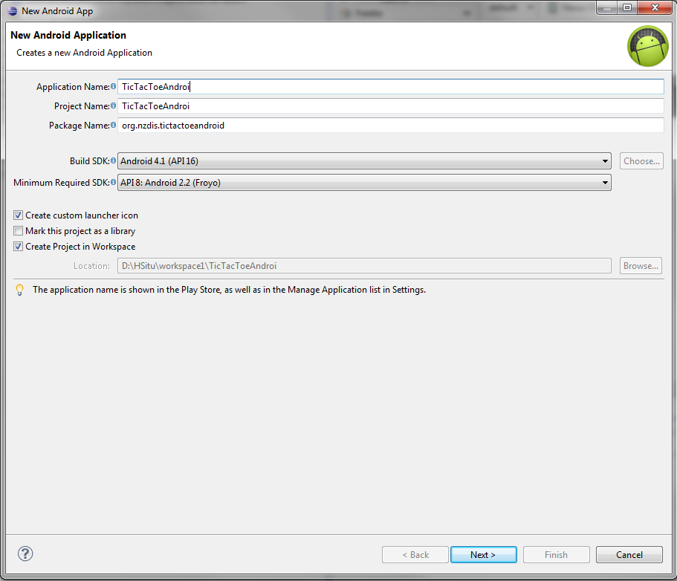

* Tick *Create custom launcher icon* and *Create Project in Workspace*
* Click *Next* to configure the application icon.
  1. Configure launcherIcon
* Choose and design your own icon for your application.
* Click *Next* to create an activity

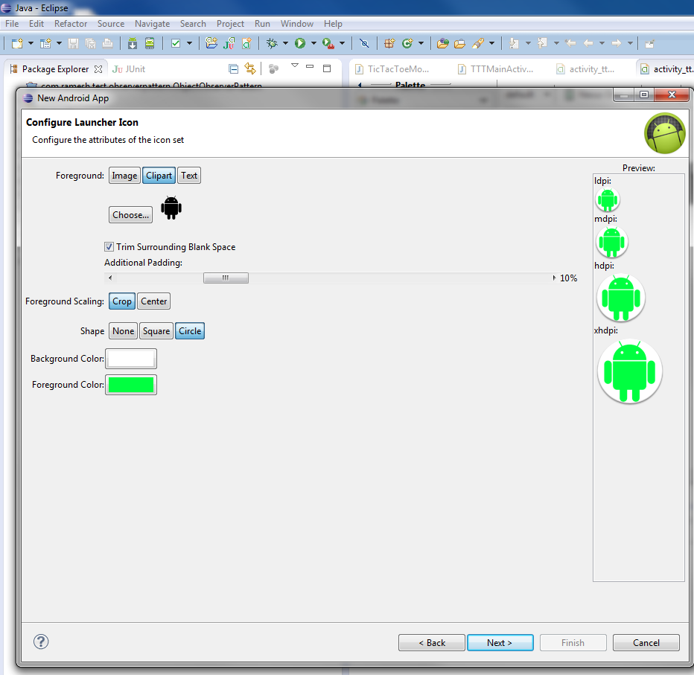

* 1. Create an Activity
* Choose *BlankActivity*
* Input names in the field of *Activity Name, Layout name* and *Title*.
  + *Activity name* is the class name of the activity
  + *Layout name* is the file name of layout saved under */res/layout*.
  + *Title* is the name of the application displayed on the screen.
* Click *finish* to finish setting up the Android project.

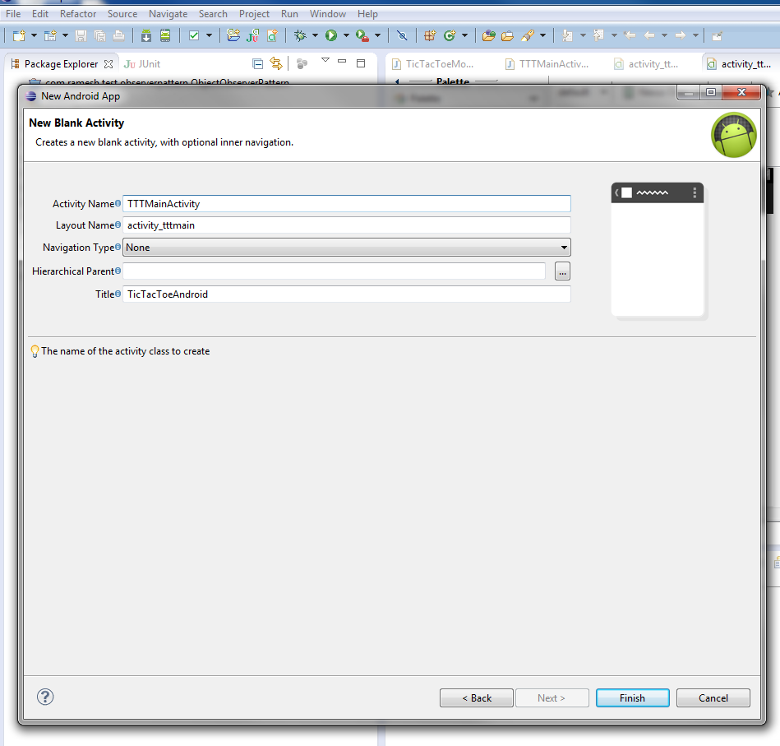

## Build Path

* 1. To develop a FragMe application, we need to add FragMe and JGroups source in the build Path. First we need to download source from GitHub and then link the source of FragMe and JGroups to the project or add jar file to the /libs directory of the project.

The source code of FragMe is at <https://github.com/NZDIS/fragme.git> and the JGroups is at <https://github.com/NZDIS/jgroups.git>. To download source from GitHub, you can refer to <http://git-scm.com/book>.

* 1. Choose Android version for the application.

Right click the project and choose *Build path->Configure build path->Android* then choose one Android version. We use Android 4.1 for this example.

## Create an Activity class

First we need to create a game interface displayed on the screens of the phones allowing users to interact with the screens. Then we need a class to handle the user input on the screen.

4.1 Create the TicTacToe game interface

Open and edit the file *activity_tttmain.xml* we created before under *res/layout/* of the project. You can choose to use Graphical layout to drag and edit buttons and text views or directly edit the .xml file. The full source code is in Appendix *Activit_tttmain.xml*

For this example, we need

* + - A TextView to display the player information.
    - A button for restart the game and start a new game. For this button, we need to set a method name for this button. When this button is clicked, the method will be invoked. The method name is given “onRestart”. In the XML file, you can see An*droid:onClick=”onRestart”* under this button.
    - Nine buttons for Tictactoe game board. We set an *onClick* method name for each button from *onPosition1* to *onPosition9.*
    - A TextView for displaying message
    - The default name of each view can be defined in the  *values/String.xml*
    - The following picture shows the graphic layout of the TicTacToe interface.

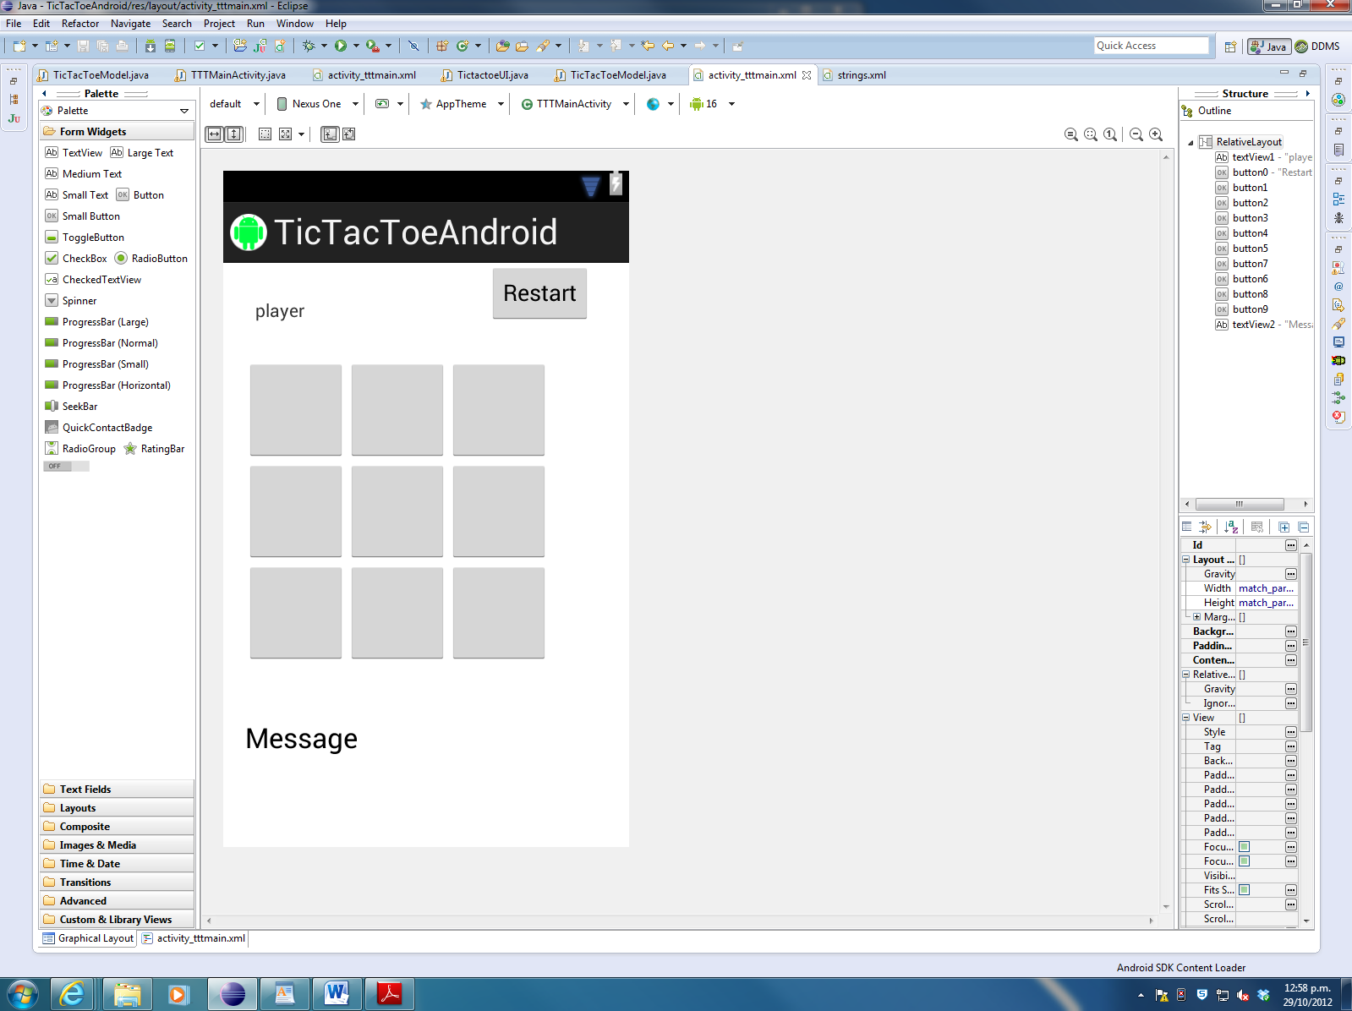

4.2 Create an Activity class which is used to initial application and handle users’ inputs.

Open and edit TTTMainActivity.java we created when we created the project. It is under the *src/org.nzdis.tictactoeAndroid/* of the project. The full source code is in Appendix *TTTMainActivity.java*

4.2.1 Activity class structure

In Android application, each activity class needs to extend *Activity* super class and implement callback methods that the system calls when the activity transitions between various states of its lifecycle. The callback methods are such as *onCreate(),* and *onDestroy().*

*onCreate():* The system calls this method to create your activity. You need to initialise the essential components of your activity.

*onDestroy():* The system calls this method when finishing your activity. You need to release some resources here.

For the TicTacToe application, we need to implement *Observer* interface, because we want to be notified when an FMObject class changed. An *update()* method of Observer needs to be implemented.

The basic structure of the class is shown as follows:

*public class TTTMainActivity extends Activity implements Observer{*

*@Override*

*public void onCreate(Bundle savedInstanceState) {*

*super.onCreate(savedInstanceState);*

*setContentView(R.layout.activity_tttmain);*

*……*

*}*

*//implement update method of Observer interface*

*public void update(Observable arg0, Object arg1) {*

*……*

*}*

*@Override*

*public void onDestroy(){*

*super.onDestroy();*

*……*

*}*

*}*

4.2.2 Link the layout with code

* Define same type of variables as they are in the *activity_tttmain.xml*.
* Use *findViewById()* to store them to the variables. Each item in the xml file has an id (@+id attribute in xml file).

*public class TTTMainActivity extends Activity implements Observer{*

*private TextView player;*

*private Button restart;*

*private Button bn1;*

*private Button bn2;*

*private Button bn3;*

***….***

*public void onCreate(Bundle savedInstanceState) {*

*super.onCreate(savedInstanceState);*

*setContentView(R.layout.activity_tttmain);*

*//get items of the activity*

*player=(TextView)findViewById(R.id.textView1);*

*restart=(Button)findViewById(R.id.button0);*

*bn1=(Button)findViewById(R.id.button1);*

*bn2=(Button)findViewById(R.id.button2);*

*bn3=(Button)findViewById(R.id.button3);*

….

*bn9=(Button)findViewById(R.id.button9);*

*messinfo=(TextView)findViewById(R.id.textView2);*

***….***

***}***

***….***

***}***

* Implement *onClick* method for each button.

For each button, it will call *buttonClick(position)* method. For example, when the first button is clicked, it will call *buttonClick(1)* with the position number 1 as parameter.

*public void onPosition1(View view) {*

*buttonClick(1);*

*}*

For each click, the method will check whether it is legal and record this move through calling *TicTacToeModel* class methods. If it is legal, we can trigger FragMe framework to change the whole object or only the changed fields of the object by calling *change()* or *change(field name).*

*private void buttonClick(int position){*

*boolean legal=false;*

*if(playerNum==1){*

*legal=tModel.OPlays(position);*

*tModel.setLastMove("O");*

*}else{*

*legal=tModel.XPlays(position);*

*tModel.setLastMove("X");*

*}*

*if(legal){*

*/*transfer the whole object. We don’t use it here because we only need to transfer two changed variables. It can save network traffic when the object is very big.*/*

*//tModel.change();*

*//transfer only changed fields*

*try{*

*tModel.change(tModel.getClass().getField("positions").getName());*

*tModel.change(tModel.getClass().getField("lastMove").getName());*

*}catch (Exception e) {*

*Log.e("TicTacToe","No such field");*

*e.printStackTrace();*

*}*

*}else{*

*//print illegal move info*

*Toast.makeText(this, "Illegal move! Wait until the other peer moves.", Toast.LENGTH_LONG).show();*

*Log.e("Tictactoe","Illegal move!");*

*}*

*this.update(tModel, null);*

*}*

4.2.3 Implement *update()* method of *Observer* interface

When the peer gets notified the object has changed, this peer will update the game interface. To display the changes in the Activity main thread, we can use *Handler* class of Android. Using method *handler.post (Runable)* is shown as follows. The thread will be queued in the main thread. For example:

*public void update(Observable arg0, Object arg1) {*

*final TicTacToeModel tttm=(TicTacToeModel)arg0;*

*hdlr.post(new Runnable() {*

*public void run(){*

*updateInterface(tttm);}*

*});*

*}*

The method *updateInterface()* is the main method to update the game interface.

*//update interface*

*private void updateInterface(TicTacToeModel model){*

*String[] positions=model.getPositions();*

*if(model.isNew_game()){*

*messinfo.setText("");*

*restart.setText("Restart");*

*}*

*for (int i=1;i<=9;i++){*

*if(positions[i].equals("X")){*

*buttons[i].setText("X");*

*buttons[i].setEnabled(false);*

*}else if (positions[i].equals("O")){*

*buttons[i].setText("O");*

*buttons[i].setEnabled(false);*

*}else {*

*buttons[i].setText(" ");*

*buttons[i].setEnabled(true);*

*}*

*if (tModel.isGameOver()){*

*buttons[i].setEnabled(false);*

*if(tModel.hasWon("X")){*

*messinfo.setText("Player 2 won!");*

*}else if (tModel.hasWon("O")){*

*messinfo.setText("Player 1 won!");*

*}else {*

*messinfo.setText("The game is tied");*

*}*

*restart.setText("New Game");*

*}*

*}*

*}*

4.2.4 Initial the application.

To play the game TicTacToe, two peers will start to connect to a group “TicTacToe” and find whether there is already a peer there. If there is no other peer, this peer will be the game starter and create the TicTacToe game. If there is already a peer there, this peer will get the copy of the TicTacToe game object from the starter. After the peer creates or gets the game object, it will update its game interface. When this sets up, it will wait for the click events and start the interactive game.

To connect to a group, the peer first needs to set its local address used to connect to the network and the peer name. The peer name could be set by users. Here we just simply get the smartphone model as the peer name.

Since FragMe is a framework using multicast protocol, before the connection we need to unlock multicast of the smartphone. To access and change network state, we must edit *AndroidManifest.xml* file under the project and add those uses permissions. The full source is in Appendix *AndroidManifest.xml*

*private void initialConnection() {*

*// set local address*

*String address = NetworkUtils*

*.getNonLoopBackAddressByProtocol(NetworkUtils.IPV4);*

*if (address == null) {*

*Log.e("tictactoe", "Could not find a local ip address");*

*return;*

*}*

*// set the peer name*

*String user = "test" + Build.MODEL;*

*// unlock multicast of the devices*

*WifiManager wifi = (WifiManager) getSystemService(Context.WIFI_SERVICE);*

*mcLock = wifi.createMulticastLock("mylock");*

*mcLock.acquire();*

*//set up connection*

*ControlCenter.setUpConnectionsWithHelper("TicTacToe", user, address,*

*new StartupWaitForObjects(1));*

*// get shared objects*

*Vector shareObs = ControlCenter.getAllObjects();*

*if (shareObs.size() == 0) {*

*tModel = new TicTacToeModel();*

*tModel = (TicTacToeModel) ControlCenter*

*.createNewObject(TicTacToeModel.class);*

*Log.i("TicTacToe", "Create a new TicTacToe object");*

*playerNum = 1;*

*player.setText("Player1 (O)");*

*} else {*

*tModel = (TicTacToeModel) shareObs.get(0);*

*Log.i("TicTacToe", "Join and share the TicTacToe object");*

*playerNum = 2;*

*player.setText("Player2 (X)");*

*}*

*// set observer of the object and update the game interface*

*tModel.addObserver(this);*

*this.update(tModel, null);*

*}*

4.2.5 Finish the application

When the application is finished, we need to close the connection and release the resource of the devices. This will be done in the *onDestroy()* method.

*public void onDestroy(){*

*super.onDestroy();*

*ControlCenter.closeUpConnections();// to close the connection*

*if (mcLock.isHeld()) {*

*mcLock.release();// to release the lock for the multicast*

*}*

*Toast.makeText(this, "Activity destroied", Toast.LENGTH_LONG).show();// to display the information*

*}*

## Create a shared object

The TicTacToe object includes all the game logic and variables. To create a new class in Eclipse, you can right click on the package name and choose *new->class*. Type class name *TicTacToeModel*. This is the shared object between peers and we want it to be transferred by the FragMe framework, so we need to extend *FMeObject* class when we create it and implement the abstract methods of superclass *FMeObject*. The full source code is in Appendix *TicTacToeModel.java*

1. The basic structure of the TicTacToe object is shown as follows:

***public******class*** *TicTacToeModel* ***extends*** *FMeObject {*

***private******static******final******long*** *serialVersionUID = 2443727758382046169L;*

*// The positions of user move*

***public*** *String[] positions = { "*", "1", "2", "3", "4", "5", "6", "7", "8",*

*"9" };*

***private******boolean*** *new_game;*

*// last move of peers*

***public*** *String lastMove = "";*

***public*** *TicTacToeModel() {*

*}*

*……*

***public******void*** *changedObject() {*

*//System.out.println("Received a change notification!");*

***this****.setChanged();*

***this****.notifyObservers();*

*}*

***public******void*** *deletedObject() {*

*//System.out.println("Received a delete notification!");*

***this****.setChanged();*

***this****.notifyObservers();*

*}*

***public******void*** *deserialize(FMeObject serObject) {*

***this****.positions = ((TicTacToeModel) serObject).getPositions();*

***this****.lastMove = ((TicTacToeModel) serObject).getLastMove();*

*}*

***private******static******class*** *Factory* ***extends*** *FragMeFactory {*

***protected*** *FactoryObject create() {*

***return******new*** *TicTacToeModel();*

*}*

*}*

***static*** *{*

*FragMeFactory.addFactory(****new*** *Factory(), TicTacToeModel.****class****);*

*}*

*}*

1. The logic of the game

The logic of the game includes deciding which player wins, whether a move is legal, and initialising variables for a new game. The methods are shown as follows:

*//Decide which player ("O" or "X") wins*

***public******boolean*** *hasWon(String anXorO) {*

*// check the rows for* ***XXX*** *or OOO*

***if*** *((positions[1].equals(anXorO)) && (positions[2].equals(anXorO))*

*&& positions[3].equals(anXorO))*

***return******true****;*

***else******if*** *((positions[4].equals(anXorO)) && (positions[5].equals(anXorO))*

*&& positions[6].equals(anXorO))*

***return******true****;*

***else******if*** *((positions[7].equals(anXorO)) && (positions[8].equals(anXorO))*

*&& positions[9].equals(anXorO))*

***return******true****;*

*// check the columns for* ***XXX*** *or OOO*

***else******if*** *((positions[1].equals(anXorO)) && (positions[4].equals(anXorO))*

*&& positions[7].equals(anXorO))*

***return******true****;*

***else******if*** *((positions[2].equals(anXorO)) && (positions[5].equals(anXorO))*

*&& positions[8].equals(anXorO))*

***return******true****;*

***else******if*** *((positions[3].equals(anXorO)) && (positions[6].equals(anXorO))*

*&& positions[9].equals(anXorO))*

***return******true****;*

*// check the diagonals for* ***XXX*** *or OOO*

***else******if*** *((positions[1].equals(anXorO)) && (positions[5].equals(anXorO))*

*&& positions[9].equals(anXorO))*

***return******true****;*

***else******if*** *((positions[3].equals(anXorO)) && (positions[5].equals(anXorO))*

*&& positions[7].equals(anXorO))*

***return******true****;*

***return******false****;*

*}*

*// Decide whether the game is over. The game is over if either "X" or "O" have a winning position or there are no more free positions*

***public******boolean*** *isGameOver() {*

***if*** *(!hasFreePositions()) {*

*lastMove = "";*

***return******true****;*

*}*

***if*** *(hasWon("X")) {*

*lastMove = "";*

***return******true****;*

*}*

***if*** *(hasWon("O")) {*

*lastMove = "";*

***return******true****;*

*}*

***return******false****;*

*}*

*// Decide whether there are free places to play on*

***private******boolean*** *hasFreePositions() {*

***boolean*** *hasFreePlacesToPlay =* ***false****;*

***for*** *(****int*** *i = 1; i < positions.length; i++)*

***if*** *(isFree(i))*

*hasFreePlacesToPlay =* ***true****;*

***return*** *hasFreePlacesToPlay;*

*}*

*//Decide whether the position is free to play on*

***private******boolean*** *isFree(****int*** *aPosition) {*

***if*** *((aPosition < 1) || (aPosition > 9))*

***return******false****; // positions are out of range*

***return*** *!((positions[aPosition].equals("X")) || (positions[aPosition]*

*.equals("O")));*

*}*

*//Make a move for "X" player if it is a free place and not the same player as last move*

***public******boolean*** *XPlays(****int*** *aPosition) {*

***if*** *(isFree(aPosition) && (!lastMove.equals("X"))) {*

*positions[aPosition] = "X";*

***return******true****;*

*}*

***return******false****;*

*}*

*//Make a move for "O" player if it is a free place and not the same player as last move*

***public******boolean*** *OPlays(****int*** *aPosition) {*

***if*** *(isFree(aPosition) && (!lastMove.equals("O"))) {*

*positions[aPosition] = "O";*

***return******true****;*

*}*

***return******false****;*

*}*

*//initial a new game*

***public******void*** *restart() {*

*positions[0] = "*";*

***for*** *(****int*** *i = 1; i <= 9; i++) {*

*positions[i] = String.valueOf(i);*

*}*

*lastMove = "";*

*}*

*// getters and setters of all variables*

***public*** *String[] getPositions() {*

***return*** *positions;*

*}*

***public******void*** *setPositions(String[] positions) {*

***this****.positions = positions;*

*}*

***public*** *String getLastMove() {*

***return*** *lastMove;*

*}*

***public******void*** *setLastMove(String lastMove) {*

***this****.lastMove = lastMove;*

*}*

***public******boolean*** *isNew_game() {*

***return******this****.new_game;*

*}*

***public******void*** *setNew_game(****boolean*** *new_game) {*

***this****.new_game = new_game;*

*}*

## Deploy and run the application

See the section of **Deploy and Run the application**of this document.

# Desktop Application Development

Developers can use the same FragMe API to develop desktop applications as well. We are now developing a desktop version of TicTacToe application as Android one talked above.

## Install Eclipse

* 1. Download Eclipse from <http://eclipse.org/downloads/> and choose Eclipse IDE for Java Developers package.
  2. Install Eclipse on local machine. You might need to install the latest Java JDK and JRE first.

## Create an Java project

Choose *File->New->Java Project*.

* Input names in the *Project Name.*
* Choose the JRE version.

Click *Next* then *Finish*

## Build Path

To develop a FragMe application, we need to add FragMe and JGroups source in the build Path. First we need to download source from GitHub and then link the source of FragMe and JGroups to the project or add jar file to the /libs directory of the project.

The source code of FragMe is at <https://github.com/NZDIS/fragme.git> and the JGroups is at <https://github.com/NZDIS/jgroups.git>. To download source from GitHub, you can refer to <http://git-scm.com/book>.

## Create a main class

First right click the project name to create a new package and then create a new class. For this example we create a class name *TictactoreUI.java*.

This class creates a game interface, sets up buttons and their *onClick* method to handle the users’ clicks, initialises the application and implements *update()* method of *Observe*r interface.

The main structure of the class is shown as follows:

***public******class*** *TictactoeUI* ***extends*** *Frame* ***implements*** *Observer {*

***public*** *TictactoeUI() {*

*//initialise interface*

*initialize();*

*//initialise connection*

*initialConnection();*

*}*

*//implement update method of Observer interface*

***public******void*** *update(Observable arg0, Object arg1) {*

***……***

***}***

***public******static******void*** *main(String[] args)* ***throws*** *IOException {*

***new*** *TictactoeUI().setVisible(****true****);*

*}*

*}*

The class uses *java.awt* to create interface including labels, buttons and buttons’ onClick methods. Those are the same elements in Android version but using *java.awt* classes.

*initialConnectin()* is used to initialise the connection and application. It is the same as it in Android version.

*Update()* is used to implement method of *Observer* interface, because this game interface needs to get notified when the shared *FMeObjec*t changed. Updating the game interface uses *java.awt* *classes*.

You can find the full source code in the Appendix *TicTacToeUI.java*

## Create a shared object

The TicTacToe object includes all the game logic and variables. It is the same as it in Android version. You simply can copy the class TicTacToeModel.java to your Java project or just link the source from your Android project to your Java project.

## Deploy and run the application

See the section of **Deploy and Run the application**of this document.

# Deploy and Run the application

## On Android phone

* 1. Start a wireless router and make sure the smartphones use the same wireless.
  2. Connect smartphones to the computer with USB cables.
  3. In Eclipse, click *Run->Run configurations*. Right click *Android Application->New*. Choose *Android* tab and click *Browse* to select project TicTacToeAndroid. Choose *Target* tab, tick *Always prompt to pick device*.
  4. Click *Run* at the bottom and then choose a smartphone from the list.

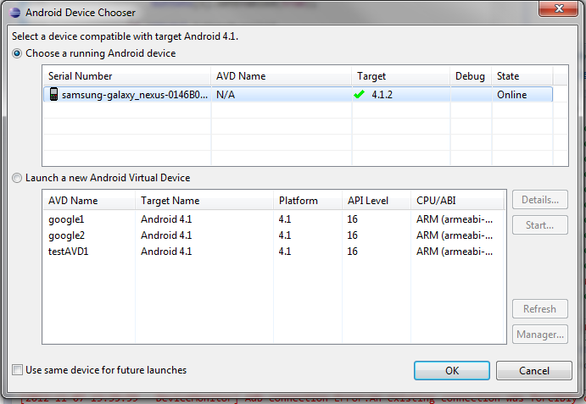

* 1. Click *OK* at the bottom. Now you can see a TicTacToe game board shown on the smartphone.
  2. After installing the application to the Android phone, you can unplug cable and play it. The picture shows two Samsung NEXUS phones playing the TicTacToe game.

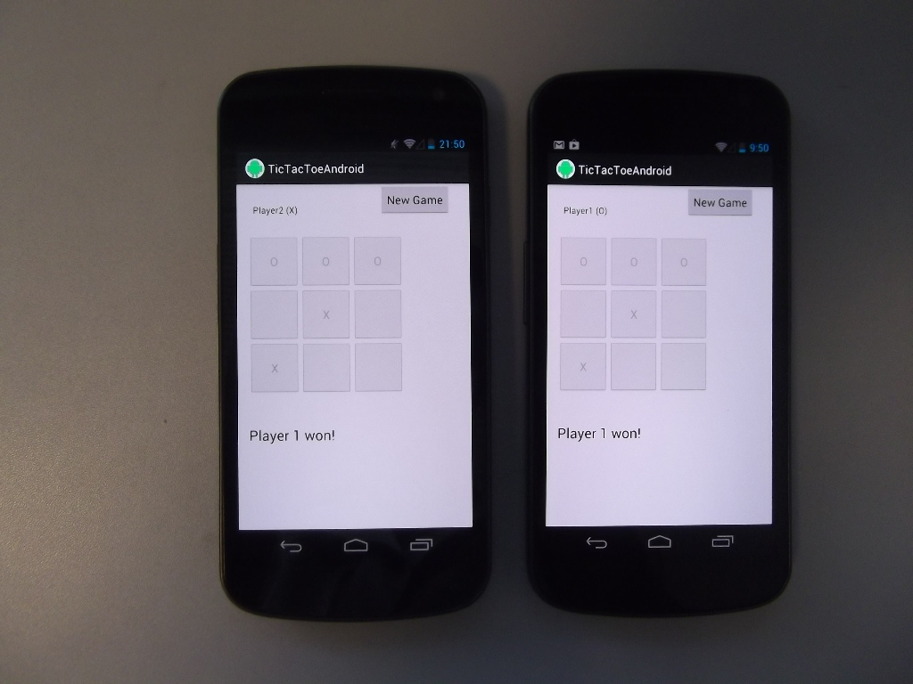

## On Desktop

Right click the project name and choose *Run as -> Java application*. You can deploy it on two PCs or you can start two instances at the local machine. When you start the application then you can play with it. The picture shows the TicTacToe game running on the same machines.

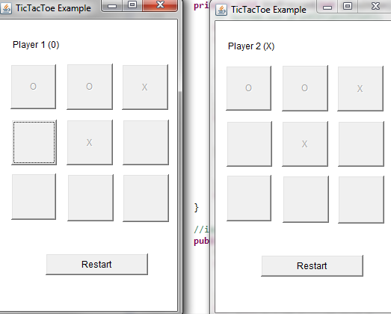

## Run the application on PCs and smartphones at the same time

We can deploy the application on a laptop and an Android phone, player can play game each other.

3.1 Start a wireless router and set up the laptop and the Android phone using the same wireless.

3.2 Run the TicTacToe desktop version on the laptop.

3.3 Run the TicTacToe Android version on the Android phone.

After two peers find each other they can start to play game.

# Appendix

## TTTMainActivity.java

public class TTTMainActivity extends Activity implements Observer{

private TextView player;

private Button restart;

private Button bn1;

private Button bn2;

private Button bn3;

private Button bn4;

private Button bn5;

private Button bn6;

private Button bn7;

private Button bn8;

private Button bn9;

private TextView messinfo;

private TicTacToeModel tModel;

private int playerNum;

private Button[] buttons=new Button[10];

private Handler hdlr=new Handler();

private MulticastLock mcLock;

@Override

public void onCreate(Bundle savedInstanceState) {

super.onCreate(savedInstanceState);

setContentView(R.layout.activity_tttmain);

//get items of the activity

player=(TextView)findViewById(R.id.textView1);

restart=(Button)findViewById(R.id.button0);

bn1=(Button)findViewById(R.id.button1);

buttons[1]=bn1;

bn2=(Button)findViewById(R.id.button2);

buttons[2]=bn2;

bn3=(Button)findViewById(R.id.button3);

buttons[3]=bn3;

bn4=(Button)findViewById(R.id.button4);

buttons[4]=bn4;

bn5=(Button)findViewById(R.id.button5);

buttons[5]=bn5;

bn6=(Button)findViewById(R.id.button6);

buttons[6]=bn6;

bn7=(Button)findViewById(R.id.button7);

buttons[7]=bn7;

bn8=(Button)findViewById(R.id.button8);

buttons[8]=bn8;

bn9=(Button)findViewById(R.id.button9);

buttons[9]=bn9;

messinfo=(TextView)findViewById(R.id.textView2);

//set up connection

initialConnection();

}

private void initialConnection() {

// set local address

String address = NetworkUtils

.getNonLoopBackAddressByProtocol(NetworkUtils.IPV4);

if (address == null) {

Log.e("tictactoe", "Could not find a local ip address");

return;

}

// set the peer name

String user = "test" + Build.MODEL;

// unlock multicast of the devices

WifiManager wifi = (WifiManager) getSystemService(Context.WIFI_SERVICE);

mcLock = wifi.createMulticastLock("mylock");

mcLock.acquire();

//set up connection

ControlCenter.setUpConnectionsWithHelper("TicTacToe", user, address,

new StartupWaitForObjects(1));

// get shared objects

Vector shareObs = ControlCenter.getAllObjects();

if (shareObs.size() == 0) {

tModel = new TicTacToeModel();

tModel = (TicTacToeModel) ControlCenter

.createNewObject(TicTacToeModel.class);

Log.i("TicTacToe", "Create a new TicTacToe object");

playerNum = 1;

player.setText("Player1 (O)");

} else {

tModel = (TicTacToeModel) shareObs.get(0);

Log.i("TicTacToe", "Join and share the TicTacToe object");

playerNum = 2;

player.setText("Player2 (X)");

}

tModel.addObserver(this);

this.update(tModel, null);

}

//buttons click handlers

public void onPosition1(View view) {

buttonClick(1);

}

public void onPosition2(View view) {

buttonClick(2);

}

public void onPosition3(View view) {

buttonClick(3);

}

public void onPosition4(View view) {

buttonClick(4);

}

public void onPosition5(View view) {

buttonClick(5);

}

public void onPosition6(View view) {

buttonClick(6);

}

public void onPosition7(View view) {

buttonClick(7);

}

public void onPosition8(View view) {

buttonClick(8);

}

public void onPosition9(View view) {

buttonClick(9);

}

public void onRestart(View view){

tModel.setNew_game(true);

tModel.restart();

tModel.change();

this.update(tModel, null);

}

//method for process handler

private void buttonClick(int position){

boolean legal=false;

if(playerNum==1){

legal=tModel.OPlays(position);

tModel.setLastMove("O");

}else{

legal=tModel.XPlays(position);

tModel.setLastMove("X");

}

if(legal){

//tModel.change(); //transfer the whole object

//transfer only changed fields

try{

tModel.change(tModel.getClass().getField("positions").getName());

tModel.change(tModel.getClass().getField("lastMove").getName());

}catch (Exception e) {

Log.e("TicTacToe","No such field");

e.printStackTrace();

}

}else{

//print illegal move info

Toast.makeText(this, "Illegal move! Wait until the other peer moves.", Toast.LENGTH_LONG).show();

Log.e("Tictactoe","Illegal move!");

}

this.update(tModel, null);

}

//implement update method of Observer interface

public void update(Observable arg0, Object arg1) {

final TicTacToeModel tttm=(TicTacToeModel)arg0;

hdlr.post(new Runnable() {

public void run(){

updateInterface(tttm);}

});

}

//update interface

private void updateInterface(TicTacToeModel model){

String[] positions=model.getPositions();

if(model.isNew_game()){

messinfo.setText("");

restart.setText("Restart");

}

for (int i=1;i<=9;i++){

if(positions[i].equals("X")){

buttons[i].setText("X");

buttons[i].setEnabled(false);

}else if (positions[i].equals("O")){

buttons[i].setText("O");

buttons[i].setEnabled(false);

}else {

buttons[i].setText(" ");

buttons[i].setEnabled(true);

}

if (tModel.isGameOver()){

buttons[i].setEnabled(false);

if(tModel.hasWon("X")){

messinfo.setText("Player 2 won!");

}else if (tModel.hasWon("O")){

messinfo.setText("Player 1 won!");

}else {

messinfo.setText("The game is tied");

}

restart.setText("New Game");

}

}

}

public void onDestroy(){

super.onDestroy();

ControlCenter.closeUpConnections();

if (mcLock.isHeld()) {

mcLock.release();

}

Toast.makeText(this, "Activity destroied", Toast.LENGTH_LONG).show();

}

}

## TicTacToeModel.java

package org.nzdis.tictactoeAndroid;

import org.nzdis.fragme.factory.FactoryObject;

import org.nzdis.fragme.factory.FragMeFactory;

import org.nzdis.fragme.objects.FMeObject;

/*

* Shared object between peers

*/

public class TicTacToeModel extends FMeObject {

private static final long serialVersionUID = 2443727758382046169L;

// The positions of user move

public String[] positions = { "*", "1", "2", "3", "4", "5", "6", "7", "8",

"9" };

private boolean new_game;

// last move of peers

public String lastMove = "";

public TicTacToeModel() {

}

//Decide which player ("O" or "X") wins

public boolean hasWon(String anXorO) {

// check the rows for XXX or OOO

if ((positions[1].equals(anXorO)) && (positions[2].equals(anXorO))

&& positions[3].equals(anXorO))

return true;

else if ((positions[4].equals(anXorO)) && (positions[5].equals(anXorO))

&& positions[6].equals(anXorO))

return true;

else if ((positions[7].equals(anXorO)) && (positions[8].equals(anXorO))

&& positions[9].equals(anXorO))

return true;

// check the columns for XXX or OOO

else if ((positions[1].equals(anXorO)) && (positions[4].equals(anXorO))

&& positions[7].equals(anXorO))

return true;

else if ((positions[2].equals(anXorO)) && (positions[5].equals(anXorO))

&& positions[8].equals(anXorO))

return true;

else if ((positions[3].equals(anXorO)) && (positions[6].equals(anXorO))

&& positions[9].equals(anXorO))

return true;

// check the diagonals for XXX or OOO

else if ((positions[1].equals(anXorO)) && (positions[5].equals(anXorO))

&& positions[9].equals(anXorO))

return true;

else if ((positions[3].equals(anXorO)) && (positions[5].equals(anXorO))

&& positions[7].equals(anXorO))

return true;

return false;

}

// Decide whether the game is over. The game is over if either "X" or "O" have a winning

// position or there are no more free positions

public boolean isGameOver() {

if (!hasFreePositions()) {

lastMove = "";

return true;

}

if (hasWon("X")) {

lastMove = "";

return true;

}

if (hasWon("O")) {

lastMove = "";

return true;

}

return false;

}

// Decide whether there are free places to play on

private boolean hasFreePositions() {

boolean hasFreePlacesToPlay = false;

for (int i = 1; i < positions.length; i++)

if (isFree(i))

hasFreePlacesToPlay = true;

return hasFreePlacesToPlay;

}

//Decide whether the position is free to play on

private boolean isFree(int aPosition) {

if ((aPosition < 1) || (aPosition > 9))

return false; // positions are out of range

return !((positions[aPosition].equals("X")) || (positions[aPosition]

.equals("O")));

}

//Make a move for "X" player if it is a free place and not the same player as last move

public boolean XPlays(int aPosition) {

if (isFree(aPosition) && (!lastMove.equals("X"))) {

positions[aPosition] = "X";

return true;

}

return false;

}

//Make a move for "O" player if it is a free place and not the same player as last move

public boolean OPlays(int aPosition) {

if (isFree(aPosition) && (!lastMove.equals("O"))) {

positions[aPosition] = "O";

return true;

}

return false;

}

//initial a new game

public void restart() {

positions[0] = "*";

for (int i = 1; i <= 9; i++) {

positions[i] = String.valueOf(i);

}

lastMove = "";

}

public void changedObject() {

//System.out.println("Received a change notification!");

this.setChanged();

this.notifyObservers();

}

public void deletedObject() {

//System.out.println("Received a delete notification!");

this.setChanged();

this.notifyObservers();

}

public void deserialize(FMeObject serObject) {

this.positions = ((TicTacToeModel) serObject).getPositions();

this.lastMove = ((TicTacToeModel) serObject).getLastMove();

}

private static class Factory extends FragMeFactory {

protected FactoryObject create() {

return new TicTacToeModel();

}

}

static {

FragMeFactory.addFactory(new Factory(), TicTacToeModel.class);

}

public String[] getPositions() {

return positions;

}

public void setPositions(String[] positions) {

this.positions = positions;

}

public String getLastMove() {

return lastMove;

}

public void setLastMove(String lastMove) {

this.lastMove = lastMove;

}

public boolean isNew_game() {

return this.new_game;

}

public void setNew_game(boolean new_game) {

this.new_game = new_game;

}

}

## activity_tttmain.xml

<RelativeLayout xmlns:android="http://schemas.android.com/apk/res/android"

xmlns:tools="http://schemas.android.com/tools"

android:layout_width="match_parent"

android:layout_height="match_parent" >

<TextView

android:id="@+id/textView1"

android:layout_width="wrap_content"

android:layout_height="wrap_content"

android:layout_alignParentLeft="true"

android:layout_alignParentTop="true"

android:layout_marginLeft="17dp"

android:layout_marginTop="21dp"

android:padding="@dimen/padding_medium"

android:text="@string/player"

tools:context=".TTTMainActivity" />

<Button

android:id="@+id/button0"

android:layout_width="wrap_content"

android:layout_height="wrap_content"

android:layout_alignParentRight="true"

android:layout_marginRight="29dp"

android:onClick="onRestart"

android:text="@string/restart" />

<Button

android:id="@+id/button1"

android:layout_width="80dp"

android:layout_height="80dp"

android:layout_alignLeft="@+id/textView1"

android:layout_below="@+id/button0"

android:layout_marginTop="28dp"

android:onClick="onPosition1" />

<Button

android:id="@+id/button2"

android:layout_width="80dp"

android:layout_height="80dp"

android:layout_alignBaseline="@+id/button1"

android:layout_alignBottom="@+id/button1"

android:layout_toRightOf="@+id/button1"

android:onClick="onPosition2" />

<Button

android:id="@+id/button3"

android:layout_width="80dp"

android:layout_height="80dp"

android:layout_alignBaseline="@+id/button2"

android:layout_alignBottom="@+id/button2"

android:layout_toRightOf="@+id/button2"

android:onClick="onPosition3" />

<Button

android:id="@+id/button4"

android:layout_width="80dp"

android:layout_height="80dp"

android:layout_alignLeft="@+id/button1"

android:layout_below="@+id/button1"

android:onClick="onPosition4" />

<Button

android:id="@+id/button5"

android:layout_width="80dp"

android:layout_height="80dp"

android:layout_below="@+id/button1"

android:layout_toRightOf="@+id/button1"

android:onClick="onPosition5" />

<Button

android:id="@+id/button7"

android:layout_width="80dp"

android:layout_height="80dp"

android:layout_below="@+id/button5"

android:layout_toLeftOf="@+id/button5"

android:onClick="onPosition7" />

<Button

android:id="@+id/button6"

android:layout_width="80dp"

android:layout_height="80dp"

android:layout_below="@+id/button2"

android:layout_toRightOf="@+id/button2"

android:onClick="onPosition6" />

<Button

android:id="@+id/button8"

android:layout_width="80dp"

android:layout_height="80dp"

android:layout_below="@+id/button5"

android:layout_toLeftOf="@+id/button6"

android:onClick="onPosition8" />

<Button

android:id="@+id/button9"

android:layout_width="80dp"

android:layout_height="80dp"

android:layout_below="@+id/button5"

android:layout_toRightOf="@+id/button5"

android:onClick="onPosition9" />

<TextView

android:id="@+id/textView2"

android:layout_width="wrap_content"

android:layout_height="wrap_content"

android:layout_alignLeft="@+id/button7"

android:layout_alignRight="@+id/button9"

android:layout_below="@+id/button8"

android:layout_marginTop="46dp"

android:text="@string/message"

android:textAppearance="?android:attr/textAppearanceLarge" />

</RelativeLayout>

## AndroidManifest.xml

<manifest xmlns:android=*"http://schemas.android.com/apk/res/android"*

package=*"org.nzdis.tictactoeAndroid"*

android:versionCode=*"1"*

android:versionName=*"1.0"* >

<uses-sdk

android:minSdkVersion=*"8"*

android:targetSdkVersion=*"15"* />

<application

android:icon=*"@drawable/ic_launcher"*

android:label=*"@string/app_name"*

android:theme=*"@style/AppTheme"* >

<activity

android:name=*".TTTMainActivity"*

android:label=*"@string/title_activity_tttmain"* >

<intent-filter>

<action android:name=*"android.intent.action.MAIN"* />

<category android:name=*"android.intent.category.LAUNCHER"* />

</intent-filter>

</activity>

</application>

<uses-permission android:name=*"android.permission.ACCESS_NETWORK_STATE"*>

</uses-permission>

<uses-permission android:name=*"android.permission.ACCESS_WIFI_STATE"*>

</uses-permission>

<uses-permission android:name=*"android.permission.CHANGE_NETWORK_STATE"*>

</uses-permission>

<uses-permission android:name=*"android.permission.CHANGE_WIFI_STATE"*>

</uses-permission>

<uses-permission android:name=*"android.permission.CHANGE_WIFI_MULTICAST_STATE"*>

</uses-permission>

<uses-permission android:name=*"android.permission.INTERNET"*></uses-permission>

<uses-permission android:name=*"android.permission.VIBRATE"*></uses-permission>

</manifest>

## TicTacToeUI.java

***package*** *org.nzdis.tictactoeDesk;*

***import*** *java.awt.Button;*

***import*** *java.awt.Frame;*

***import*** *java.awt.Label;*

***import*** *java.awt.Panel;*

***import*** *java.awt.Rectangle;*

***import*** *java.io.IOException;*

***import*** *java.util.Observable;*

***import*** *java.util.Observer;*

***import*** *java.util.Vector;*

***import*** *org.nzdis.fragme.ControlCenter;*

***import*** *org.nzdis.fragme.helpers.StartupWaitForObjects;*

***import*** *org.nzdis.fragme.util.NetworkUtils;*

**import** org.nzdis.tictactoeDesk.TicTacToeModel;

***public******class*** *TictactoeUI* ***extends*** *Frame* ***implements*** *Observer {*

***private*** *TicTacToeModel tModel;*

***private******int*** *player;*

***private*** *Panel jContentPane =* ***null****;*

***private*** *Button btn1 =* ***null****;*

***private*** *Button btn2 =* ***null****;*

***private*** *Button btn3 =* ***null****;*

***private*** *Button btn4 =* ***null****;*

***private*** *Button btn5 =* ***null****;*

***private*** *Button btn6 =* ***null****;*

***private*** *Button btn7 =* ***null****;*

***private*** *Button btn8 =* ***null****;*

***private*** *Button btn9 =* ***null****;*

***private*** *Button[] buttons =* ***new*** *Button[10];*

***private*** *Label lblPlayer =* ***null****;*

***private*** *Label lblWinMsg =* ***null****;*

***private*** *Button btnRestart =* ***null****;*

*/\*\**

*\* This is the default constructor*

*\*/*

***public*** *TictactoeUI() {*

*//initialize interface*

*initialize();*

*initialConnection();*

*}*

***public******void*** *initialConnection(){*

*//set connection address*

*String address = NetworkUtils.getNonLoopBackAddressByProtocol(NetworkUtils.IPV4);*

***if*** *(address ==* ***null****) {*

*System.out.println("Could not find a local ip address");*

***return****;*

*}*

*//set peer name*

*String username = System.getProperty("user.name");*

*//set up connection*

*ControlCenter.setUpConnectionsWithHelper("TicTacToe", username, address,* ***new*** *StartupWaitForObjects(1));*

*//get shared object*

*Vector shareObjects = ControlCenter.getAllObjects();*

***if*** *(shareObjects.size() == 0) {*

*tModel=****new*** *TicTacToeModel();*

***this****.tModel = (TicTacToeModel) ControlCenter*

*.createNewObject(TicTacToeModel.****class****);*

*System.out.println("Create new tictactoemodel:" +* ***this****.tModel.toString());*

***this****.player = 1;*

*System.out.println("I am player 1 (0)");*

*lblPlayer.setText("Player 1 (0)");*

*}* ***else*** *{*

***this****.tModel = (TicTacToeModel) shareObjects.get(0);*

*System.out.println("Joining the existing game:"*

*+ shareObjects.get(0).toString());*

***this****.player = 2;*

*System.out.println("I am player 2 (X).");*

*lblPlayer.setText("Player 2 (X)");*

*}*

***this****.tModel.addObserver(****this****);*

***this****.update(tModel,* ***null****);*

*}*

*/\*\**

*\* This method initializes this*

*\**

*\** ***@return*** *void*

*\*/*

***private******void*** *initialize() {*

***this****.add(getJContentPane());*

***this****.setTitle("TicTacToe Example");*

***this****.setBounds(****new*** *Rectangle(20, 20, 253, 428));*

*}*

*/\*\**

*\* This method initializes jContentPane*

*\**

*\** ***@return*** *java.awt.Panel*

*\*/*

***private*** *Panel getJContentPane() {*

***if*** *(jContentPane ==* ***null****) {*

*lblWinMsg =* ***new*** *Label();*

*lblWinMsg.setBounds(****new*** *Rectangle(15, 281, 209, 19));*

*lblWinMsg.setText("");*

*lblPlayer =* ***new*** *Label();*

*lblPlayer.setBounds(****new*** *Rectangle(15, 20, 163, 28));*

*lblPlayer.setText("");*

*jContentPane =* ***new*** *Panel();*

*jContentPane.setLayout(****null****);*

*jContentPane.add(getBtn1(),* ***null****);*

*jContentPane.add(getBtn2(),* ***null****);*

*jContentPane.add(getBtn3(),* ***null****);*

*jContentPane.add(getBtn4(),* ***null****);*

*jContentPane.add(getBtn5(),* ***null****);*

*jContentPane.add(getBtn6(),* ***null****);*

*jContentPane.add(getBtn7(),* ***null****);*

*jContentPane.add(getBtn8(),* ***null****);*

*jContentPane.add(getBtn9(),* ***null****);*

*jContentPane.add(lblPlayer,* ***null****);*

*jContentPane.add(lblWinMsg,* ***null****);*

*jContentPane.add(getBtnRestart(),* ***null****);*

*}*

***return*** *jContentPane;*

*}*

*/\*\**

*\* This method initializes btn1*

*\**

*\** ***@return*** *java.awt.Button*

*\*/*

***private*** *Button getBtn1() {*

***if*** *(btn1 ==* ***null****) {*

*btn1 =* ***new*** *Button();*

*btn1.setBounds(****new*** *Rectangle(14, 60, 61, 60));*

*btn1.addActionListener(****new*** *java.awt.event.ActionListener() {*

***public******void*** *actionPerformed(java.awt.event.ActionEvent e) {*

*btnPressed(1);*

*}*

*});*

*}*

*buttons[1] = btn1;*

***return*** *btn1;*

*}*

*/\*\**

*\* This method initializes btn2*

*\**

*\** ***@return*** *java.awt.Button*

*\*/*

***private*** *Button getBtn2() {*

***if*** *(btn2 ==* ***null****) {*

*btn2 =* ***new*** *Button();*

*btn2.setBounds(****new*** *Rectangle(89, 59, 62, 62));*

*btn2.addActionListener(****new*** *java.awt.event.ActionListener() {*

***public******void*** *actionPerformed(java.awt.event.ActionEvent e) {*

*btnPressed(2);*

*}*

*});*

*}*

*buttons[2] = btn2;*

***return*** *btn2;*

*}*

*/\*\**

*\* This method initializes btn3*

*\**

*\** ***@return*** *java.awt.Button*

*\*/*

***private*** *Button getBtn3() {*

***if*** *(btn3 ==* ***null****) {*

*btn3 =* ***new*** *Button();*

*btn3.setBounds(****new*** *Rectangle(163, 60, 62, 61));*

*btn3.addActionListener(****new*** *java.awt.event.ActionListener() {*

***public******void*** *actionPerformed(java.awt.event.ActionEvent e) {*

*btnPressed(3);*

*}*

*});*

*}*

*buttons[3] = btn3;*

***return*** *btn3;*

*}*

*/\*\**

*\* This method initializes btn4*

*\**

*\** ***@return*** *java.awt.Button*

*\*/*

***private*** *Button getBtn4() {*

***if*** *(btn4 ==* ***null****) {*

*btn4 =* ***new*** *Button();*

*btn4.setBounds(****new*** *Rectangle(15, 134, 61, 61));*

*btn4.addActionListener(****new*** *java.awt.event.ActionListener() {*

***public******void*** *actionPerformed(java.awt.event.ActionEvent e) {*

*btnPressed(4);*

*}*

*});*

*}*

*buttons[4] = btn4;*

***return*** *btn4;*

*}*

*/\*\**

*\* This method initializes btn5*

*\**

*\** ***@return*** *java.awt.Button*

*\*/*

***private*** *Button getBtn5() {*

***if*** *(btn5 ==* ***null****) {*

*btn5 =* ***new*** *Button();*

*btn5.setBounds(****new*** *Rectangle(89, 134, 62, 61));*

*btn5.addActionListener(****new*** *java.awt.event.ActionListener() {*

***public******void*** *actionPerformed(java.awt.event.ActionEvent e) {*

*btnPressed(5);*

*}*

*});*

*}*

*buttons[5] = btn5;*

***return*** *btn5;*

*}*

*/\*\**

*\* This method initializes btn6*

*\**

*\** ***@return*** *java.awt.Button*

*\*/*

***private*** *Button getBtn6() {*

***if*** *(btn6 ==* ***null****) {*

*btn6 =* ***new*** *Button();*

*btn6.setBounds(****new*** *Rectangle(164, 134, 62, 61));*

*btn6.addActionListener(****new*** *java.awt.event.ActionListener() {*

***public******void*** *actionPerformed(java.awt.event.ActionEvent e) {*

*btnPressed(6);*

*}*

*});*

*}*

*buttons[6] = btn6;*

***return*** *btn6;*

*}*

*/\*\**

*\* This method initializes btn7*

*\**

*\** ***@return*** *java.awt.Button*

*\*/*

***private*** *Button getBtn7() {*

***if*** *(btn7 ==* ***null****) {*

*btn7 =* ***new*** *Button();*

*btn7.setBounds(****new*** *Rectangle(15, 206, 60, 62));*

*btn7.addActionListener(****new*** *java.awt.event.ActionListener() {*

***public******void*** *actionPerformed(java.awt.event.ActionEvent e) {*

*btnPressed(7);*

*}*

*});*

*}*

*buttons[7] = btn7;*

***return*** *btn7;*

*}*

*/\*\**

*\* This method initializes btn8*

*\**

*\** ***@return*** *java.awt.Button*

*\*/*

***private*** *Button getBtn8() {*

***if*** *(btn8 ==* ***null****) {*

*btn8 =* ***new*** *Button();*

*btn8.setBounds(****new*** *Rectangle(90, 207, 62, 63));*

*btn8.addActionListener(****new*** *java.awt.event.ActionListener() {*

***public******void*** *actionPerformed(java.awt.event.ActionEvent e) {*

*btnPressed(8);*

*}*

*});*

*}*

*buttons[8] = btn8;*

***return*** *btn8;*

*}*

*/\*\**

*\* This method initializes btn9*

*\**

*\** ***@return*** *java.awt.Button*

*\*/*

***private*** *Button getBtn9() {*

***if*** *(btn9 ==* ***null****) {*

*btn9 =* ***new*** *Button();*

*btn9.setBounds(****new*** *Rectangle(164, 207, 62, 64));*

*btn9.addActionListener(****new*** *java.awt.event.ActionListener() {*

***public******void*** *actionPerformed(java.awt.event.ActionEvent e) {*

*btnPressed(9);*

*}*

*});*

*}*

*buttons[9] = btn9;*

***return*** *btn9;*

*}*

***private******void*** *btnPressed(****int*** *aPosition) {*

*// System.out.println(position);*

***boolean*** *legal =* ***false****;*

***if*** *(player == 1) {*

*legal = tModel.OPlays(aPosition);*

*tModel.setLastMove("O");*

*}* ***else*** *{*

*legal = tModel.XPlays(aPosition);*

*tModel.setLastMove("X");*

*}*

***if*** *(legal) {*

*tModel.change();*

*}* ***else*** *{*

*System.out.println("Illegal move!");*

*}*

***this****.update(tModel,* ***null****);*

*}*

*//implement update method of Observer interface*

***public******void*** *update(Observable arg0, Object arg1) {*

*String[] positions = tModel.getPositions();*

***if*** *(tModel.isNew_game()) {*

*lblWinMsg.setText("");*

*btnRestart.setLabel("Restart");*

*}*

***for*** *(****int*** *i = 1; i <= 9; i++) {*

***if*** *(positions[i].equals("X")) {*

*buttons[i].setLabel("X");*

*buttons[i].setEnabled(****false****);*

*}* ***else******if*** *(positions[i].equals("O")) {*

*buttons[i].setLabel("O");*

*buttons[i].setEnabled(****false****);*

*}* ***else*** *{*

*buttons[i].setLabel("");*

*buttons[i].setEnabled(****true****);*

*}*

***if*** *(tModel.isGameOver()) {*

*buttons[i].setEnabled(****false****);*

***if*** *(tModel.hasWon("X")) {*

*lblWinMsg.setText("Player 2 won!");*

*}* ***else******if*** *(tModel.hasWon("O")) {*

*lblWinMsg.setText("Player 1 won!");*

*}* ***else*** *{*

*lblWinMsg.setText("The game is tied.");*

*}*

*btnRestart.setLabel("New Game?");*

*}*

*}*

*}*

*/\*\**

*\* This method initializes btnRestart*

*\**

*\** ***@return*** *java.awt.Button*

*\*/*

***private*** *Button getBtnRestart() {*

***if*** *(btnRestart ==* ***null****) {*

*btnRestart =* ***new*** *Button();*

*btnRestart.setBounds(****new*** *Rectangle(61, 313, 137, 29));*

*btnRestart.setLabel("Restart");*

*btnRestart.addActionListener(****new*** *java.awt.event.ActionListener() {*

***public******void*** *actionPerformed(java.awt.event.ActionEvent e) {*

*btnRestartPressed();*

*}*

*});*

*}*

***return*** *btnRestart;*

*}*

***private******void*** *btnRestartPressed() {*

*System.out.println("restart pressed");*

*tModel.setNew_game(****true****);*

*tModel.restart();*

*tModel.change();*

***this****.update(tModel,* ***null****);*

*}*

***public******static******void*** *main(String[] args)* ***throws*** *IOException {*

***new*** *TictactoeUI().setVisible(****true****);*

*}*

}